Приложение 3
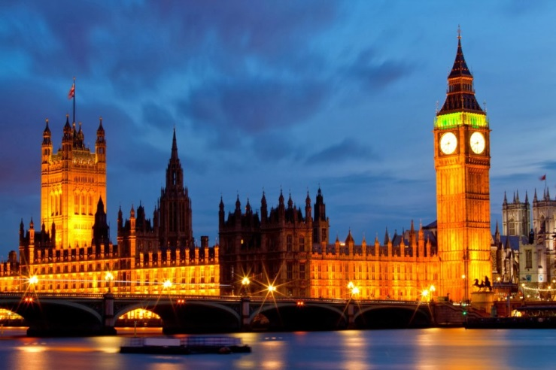
1. The Big Ben («Биг Бен»).
The world-known clock. Everyday about 500 tourists come to London to see the Big Ben. Built in 1858, it was named after an architect whose name was Ben (Benjamin). The interesting fact is that you are not allowed to get inside the Big Ben if you aren’t an Englishman. No tourists allowed.

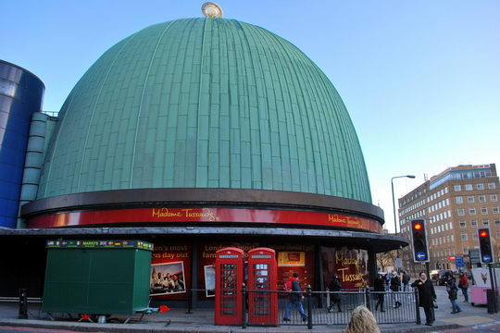
2. Madam Tussaud's Museum (Музей Мадам Тюссо).
The most famous museum of waxworks. It presents all famous people from singers and actors to Prime Ministers and Presidents. All the waxworks are of such a good quality, that sometimes you can mistake them for a real person.

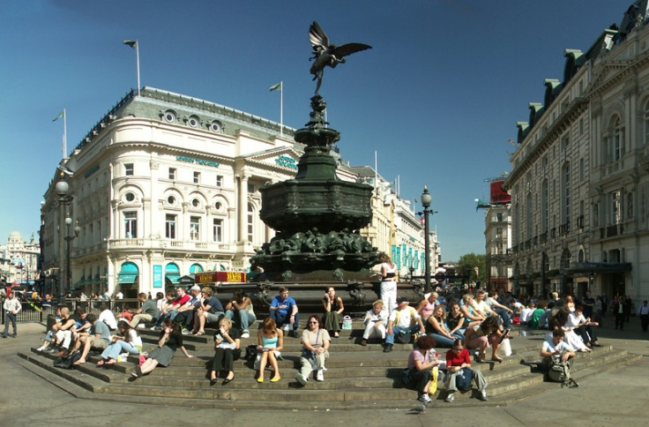
3. Piccadilly Circus
(Площадь Пикадилли).
The place is far from what is called “a circus”. It is a well-known meeting point of the city. It has become so popular, that is now considered to be a place to visit for all the tourists.

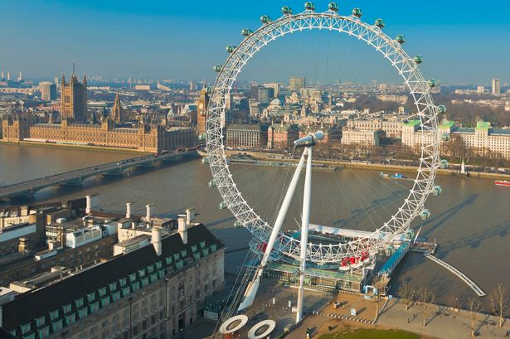
4. London Eye
(Лондонское колесо обозрения).
It is one of the biggest observation wheels in the world. Its height is 135 meters. It has 32 cabins which symbolize 32 districts of London. It takes 30 minutes to make a full circle. But it is the view you will never forget. The cost is about £20.

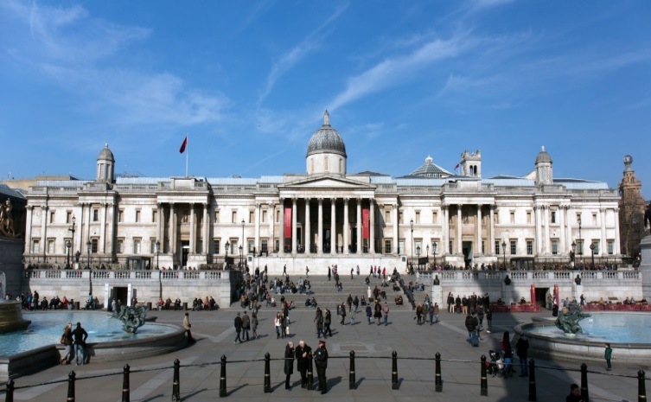
5. London National Gallery (Лондонская Национальная Галерея).
The gallery has more than 2000 works of world-known artists of XIII-XX centuries. You can spend the whole day there and it will not be enough. What is interesting, is that the gallery is free for everyone.

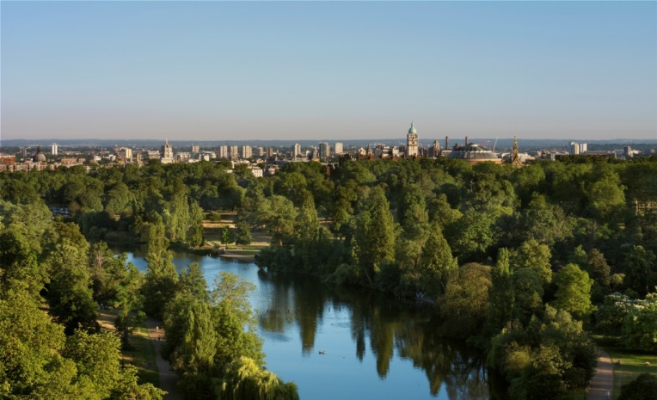
6. Parks of London
(Парки Лондона).
London is famous for its parks. Combined, all these parks cover more land than the Principality of Monaco. The most well-known is the Hyde Park. It is a traditional place of festivals and celebrations.

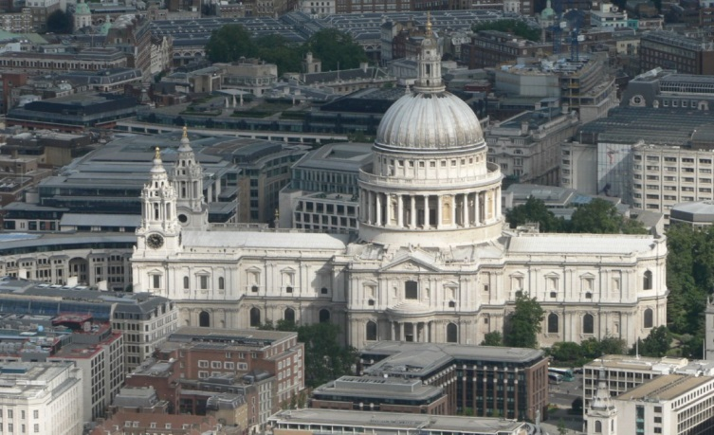
7. St. Paul’s Cathedral (Собор Святого Павла).
It was built on the highest point of London 300 years ago. It is the London Bishop’s residence and is the most popular place of visit. The price of visit is £16.

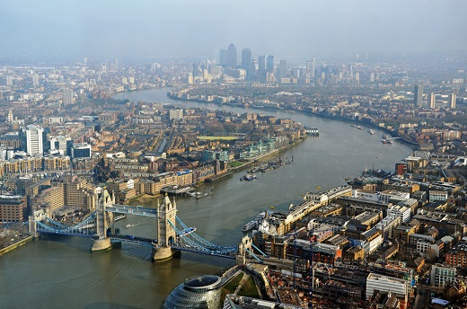
8. The Thames (Река Темза).
The longest and most famous river in the UK which the British often call the «Father Thames». In 1894 Tower Bridge was opened, and in 2012 a modern cableway was built over it. Popular tourist activities are river excursions and water-bus or boat trips. Every year one can watch here the boat race between Oxford and Cambridge universities.

