Приложение 1

FOR MEMORIES THAT LAST MORE THAN 90 MINUTES
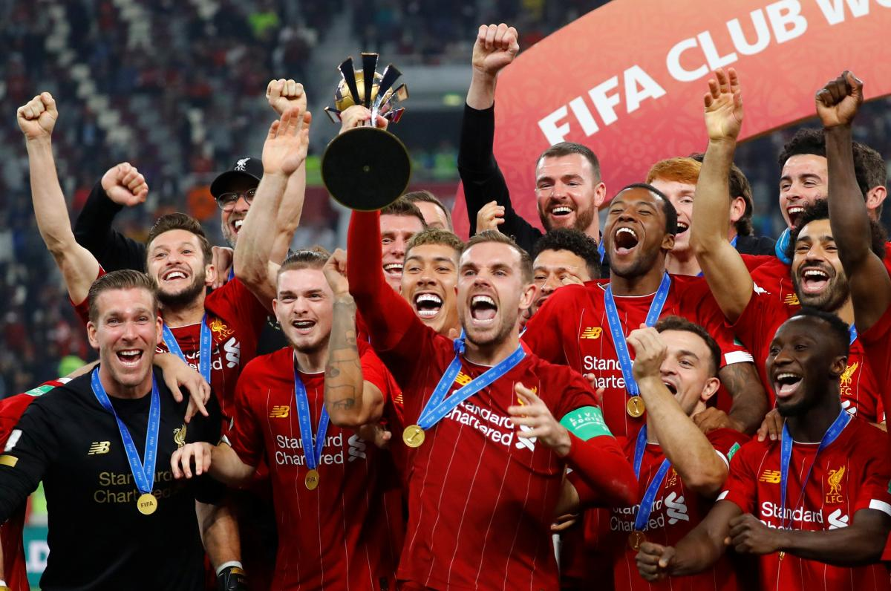
There's something special about Liverpool Football Club, the electric atmosphere, the excitement and the passion. https://www.liverpoolfc.com/news
As a match day VIP, you'll combine the buzz of a match day with exceptional hospitality and a feast of football, giving you a unique and memorable experience.
Our range of hospitality packages suit all needs and requirements, so whether you're treating yourself or family, looking to book for a group celebration or entertaining clients, there's a season packed full of exciting fixtures to choose from. Whichever option you choose you can be sure of a match day experience that combines first class hospitality, thrilling football and a day to remember. Don’t miss out on any of the action this season. See our available packages by fixture or have a look at our hospitality lounges and venues.

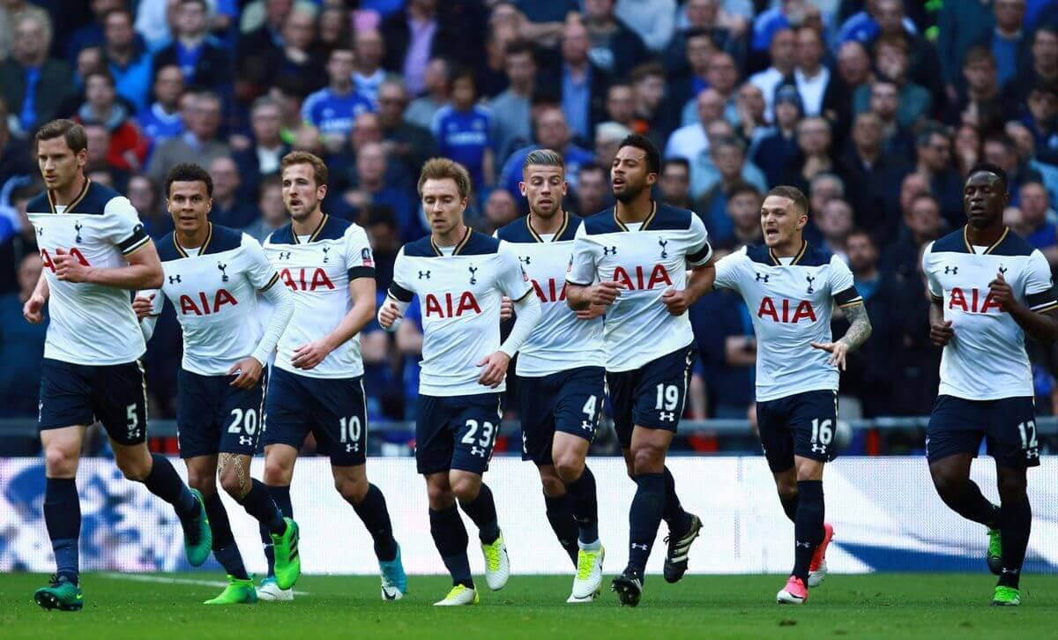
Tottenham Hotspur Football Club
The words of our 1961 Double-winning captain Danny Blanchflower reverberate around Tottenham Hotspur and everything we do, to this day and into the future.
We are about playing with flair, style and passion. Players, coaches, staff and fans – we move forward, together as one.
https://www.tottenhamhotspur.com
We’re so proud of our rich history. From humble beginnings in North London, we became the first and, to date, only non-league side to win the FA Cup in 1901 – the first of eight triumphs in the age-old, world-renowned competition thus far.
We’re hungry, we’re progressive, we’ve built a brand new world-class Training Centre and moved into an outstanding, modern new stadium, overlapping the site of White Hart Lane, where we played our home games for 118 years.

